Unit Content Testing quick guide (Phase 2 and 3 Units)
Unit Content Testing will follow the process as outlined below.
A simple summary of key dates is included here.

Step-by-step process for Unit Content Testing
Figure 1: Process for formal Unit Content Testing for Phase 2 and 3 Units
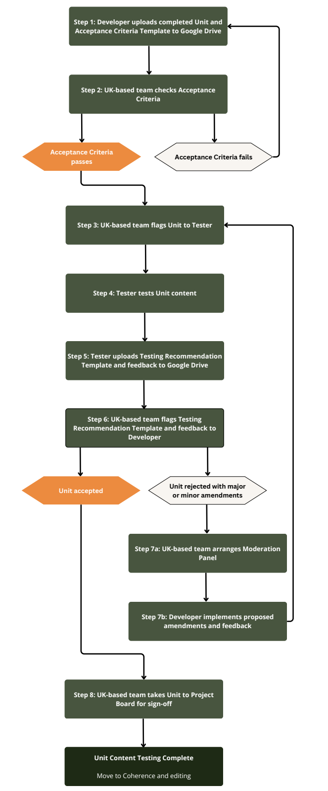

Step 1: Developer uploads completed Unit and Acceptance Criteria Template to Google Drive
- A Unit must be fully drafted and as close to a ‘final’ version as possible.
- The Developer must review the Unit and complete the Acceptance criteria template to confirm that it meets the standards required for submission.
- Developers are expected to specify any additional criteria they would like the Tester to check at the end of the Acceptance criteria template. These should be criteria that relate specifically to that Unit, for example, whether a process diagram makes sense to the user. Once approved by the UK Analysis for Action team, these criteria will be added to the Testing Recommendation Template that gets shared with the Tester.
- The Developer must then submit the Unit and all its content to the Analysis for Action Google Drive, including but not limited to: written content; any images; videos; audio recordings; code; and interactive objects. Code should be pushed to a branch dedicated to that Unit on the Analysis for Action Github.
- For Phase 1 Units, the deadline to submit Units is 30th September 2025 latest. For Phase 2 and 3 Units, the deadline is 31st July 2026 latest.

Step 2: UK-based team checks Acceptance Criteria
- The UK Analysis for Action team will then review the completed Acceptance criteria template.
- If the UK Analysis for Action team agrees with the additional checks requested by the Developer, they will add these to the Testing Recommendation Template for that Unit.
- They will also check whether the content will be compatible with the online platform.
- The Unit will then be either approved or rejected.
  - If approved, go to step 3.
  - If rejected, the UK Analysis for Action team will share feedback with the Developer on how they need to refine the Unit content and Acceptance Criteria for the submission to be approved. The Developer will then need to implement these suggestions and upload updated versions as soon as possible to avoid further delays.
- For Phase 1 Units, the UK Analysis for Action team will finish reviewing the completed Acceptance Criteria templates for all Units by 7th October 2025 latest. For Phase 2 and 3 Units, the deadline is 7th August 2026 latest.

Step 3: UK-based team flags Unit to Tester
- The UK Analysis for Action team will then flag that the Unit is ready for testing.
- The Tester will lead on Unit Content Testing, with the NSO contributing to any final recommendations (though not being involved directly in testing the Units themselves).
- For Phase 1 Units, the UK Analysis for Action team will flag Units to Testers by 7th October 2025. For Phase 2 and 3 Units, this will be by 7th August 2026.

Step 4: Tester tests Unit content
For Phase 1 Units: The DP Tester has four weeks to test and upload feedback on all Units assigned to them.
UPDATE for Phase 2 and 3 Units: Testers have four weeks to test content in the first round of testing. In subsequent second and third rounds of testing (re-testing), they will have two weeks. Re-testing should focus on whether your feedback and proposed amendments have been implemented: you do not need to re-test content that has not been changed.
It is at the DP’s discretion when below steps 4a, 4b, and 4c are taken. The weeks in brackets below are presented as suggestions.

Step 4a: DP testing (Suggest Weeks One & Two)
- The Tester conducts an in-depth review of the Unit’s content. This should be done by:
  - Completing checks outlined in the Testing Recommendation Template, which may include additional checks requested by the Developer.
  - Testers utilising their own expertise to identify and complete additional checks not already captured in the Testing Recommendation Template. In other words, are there any checks that the Developer may not have considered but you feel is important? If so, these should also be recorded in the Testing Recommendation Template.
  - Consulting experts in the Unit subject matter to quality assure and verify the technical accuracy of its content. If any additional checks are identified by experts, and completed by the Tester, these should also be recorded in the Testing Recommendation Template.
  - Leaving feedback for Developers via in-document comments is also strongly encouraged.
  - For Phase 2/3 Units: If the Tester has the technical knowledge required, they are also encouraged to draft changes or new content they have proposed as an amendment.

Step 4b: DP Tester & NSO to meet and agree recommendation (Suggest Week Three)
- The Tester must then meet with their NSO to showcase the Unit and discuss findings from their review, including any proposed amendments.
- The Tester and the NSO must then agree on a final recommendation for the Unit. A Unit can be:
  - Accepted;
  - Rejected with minor amendments; or
  - Rejected with major amendments.

Step 4c: DP to complete Testing Recommendation Template (Suggest Week Four)
- The Tester must then populate the Testing Recommendation Template with the outcomes of their testing as per the steps outlined in 4a and 4b. This should include any proposed amendments.
- For Phase 1 Units: The Tester should assess the time required to implement the proposed amendments to an acceptable standard.
  - If the DP Tester determines that the necessary changes can be completed within one month, they should recommend rejected with minor amendments.
  - If the Tester estimates that the amendments would take longer than one month, they should recommend rejected with major amendments.
- For Phase 2 and 3 Units: the Tester should assess the scale of amendments proposed.
  - If the DP Tester determines that the amendments are minor, and there is only a small number of them, they should recommend rejected with minor amendments.
  - If the Tester determines that the amendments are major, or there are a large number of minor amendments, they should recommend rejected with major amendments.
For Phase 2 and 3 Units, it may not be possible to liaise with the NSO during the two week rounds of re-testing. If this is the case please inform the UK team and DP Developer when delivering your feedback.

Step 5: Tester uploads Testing Recommendation Template and feedback to Google Drive
- Once the Testing Recommendation Template is complete, the Tester must upload it to the Google Drive for the UK Analysis for Action team to review.
- The UK Analysis for Action team will then review the Testing Recommendation Template. If they agree with the Tester’s judgements, the Template will be signed off and the Tester’s recommendation will be taken forward. A Unit can be:
  - Accepted;
  - Rejected with minor amendments; or
  - Rejected with major amendments.
- For Phase 1 Units, completed Testing Recommendation Templates must be uploaded by 4th November 2025 latest. For Phase 2 and 3 Units, the deadline is 4th September 2026 latest.

Step 6: UK-based team flags Testing Recommendation Template and feedback to Developer
- The UK Analysis for Action team will then flag the completed Testing Recommendation Template and any Unit files with in-document comments to the Developer.
- Once received the Developer should use this time to review the findings of the Tester and UK Analysis for Action team.
- If the Unit has been rejected and amendments have been proposed, the Developer should prepare any questions they may have for the Tester to discuss at the upcoming Moderation Panel.
- Testing Recommendation Templates and commented files will be flagged to the Developer by 11th November 2025 for Phase 1 Units. For Phase 2 and 3 Units, this date is 11th September 2026.
- If a Unit is Accepted, go to step 8.
- If a Unit is rejected, go to step 7a.

Step 7a (if a Unit is rejected): UK-based team arranges Moderation Panel
- If a Unit is rejected after the first round of development, the UK Analysis for Action team will arrange a Moderation Panel between the UK Analysis for Action team, the Unit Developer, Tester, and any members of TAG or other experts who may have contributed to the proposed amendments.
- The duration of the meeting with depend on the number of Units to be discussed at Panel. Each Unit will be allocated one hour for discussion to ensure adequate time is dedicated.
- Responsibilities of each group are as follows:
  - Chair: The UK-based Analysis for Action team will chair all Moderation Panels, finalise the agenda and take notes and actions.
  - Tester responsibility: Presenting their recommendation and explaining amendments required to the Delivery Partner Developer on the Testing Recommendation Template. If joined by UK TAG members or other experts, they will also be given the opportunity to contribute.
  - Developer responsibility: To listen to the recommendation presented by the Tester and ensure they understand the amendments required. Following the Moderation Panel the Developer is expected to make any agreed amendments and return them to the UK Analysis for Action Team and Delivery Partner Tester:
    - For Phase 1 Units:
      - Within one month for minor amendments; or
      - Within two months for major amendments.
    - For Phase 2 Units:
      - Within two months regardless of whether minor or major amendments have been proposed.
- The first round of Moderation Panels for Phase 1 Units will be held from 18th to 25th November 2025. For Phase 2 and 3 Units these will be held from 11th to 18th September 2026.
- Moderation Panels will only be arranged in the first instance that a Unit has been rejected (after one round of development). They will only be arranged after subsequent rejections if requested by the Developer. However, partners are encouraged to arrange their own meetings and use the Google Chat for any further discussion required.

Step 7b (if a Unit is rejected): Developer implements proposed amendments and feedback
- The Developer must implement the Tester’s amendments and then re-submit the Unit to the Google Drive when done. This must be done:
    - For Phase 1 Units:
      - Within one month for minor amendments; or
      - Within two months for major amendments.
    - UPDATE for Phase 2 Units:
      - For the second round of development, within six weeks regardless of whether minor or major amendments have been proposed.
      - For the third round of development, within four weeks regardless of whether minor or major amendments have been proposed.
  - Once the Tester has received the updated Unit, they must repeat Steps 4 to 5. Importantly, the Tester must complete section 2 of the Testing Recommendation Template, confirming whether the amendments have been successfully implemented. As before, a Unit can be:
  - Accepted;
  - Rejected with minor amendments; or
  - Rejected with major amendments.
- For Phase 1 Units:
  - Minor amendments must be implemented and the Unit re-submitted by 31st December 2025.
  - Major amendments must be implemented and the Unit re-submitted by 26th January 2026.
- UPDATE for Phase 2 and 3 Units: After the first round of testing, amendments must be implemented and the Unit re-submitted by 30th October 2026. It will then enter a second round of testing.
- If a Unit is still rejected after the second round of testing, it will enter a third and final round of development. If a Unit is rejected after the third round then the UK team will review and a second DP Tester may be asked to test the Unit as a further quality assurance check of the Unit. Developers must upload finalised versions of all Phase 2 and 3 Units by 11th December latest to prevent delays to wider project timelines.

Step 8: UK-based team takes Unit to Project Board for sign-off
- Once the Unit content has been accepted then the UK Analysis for Action team will take the Tester’s recommendation to the next Project Board for final sign off.
- Unit Content Testing is now complete, and Coherence and Editing will begin.
- If you have any questions about the process for Unit Content Testing, please get in touch.

Summary of key dates
Key dates for Unit content development and testing are summarised below:
- First round of Unit development ends and Developers upload content and Acceptance Criteria Template: 31st July 2026
- UK team flags Units ready for testing: 7th August
- First round of Unit Content Testing ends and Testers upload Testing Recommendation Template and feedback: 4th September
- Moderation panels: 11th to 18th September
- Second round of Unit development ends and Developers upload updated content: 30th October (six weeks)
- Second round of testing ends and Testers upload updated Testing Recommendation Template and feedback: 13th November (two weeks)
- Third and final round of Unit development ends and Developers upload updated content: 11th December (four weeks)
- Third and final round of testing ends and Testers upload updated Testing Recommendation Template and feedback: 31st December 2026 (two weeks not including Christmas)
These dates are also plotted in the table below.
Stage | First round | Second round | Third round (final)
Development | 6 months  Deadline: 31st Jul  Upload content + Acceptance Criteria | 6 weeks  Deadline: 30th Oct  Amend content | 4 weeks  Deadline: 11th Dec  Final amendments
Testing | 4 weeks  Deadline: 4th Sep  Upload testing template + feedback | 2 weeks  Deadline: 13th Nov  Upload Section 2 | 2 weeks  Deadline: 31st Dec  Duplicate and upload additional Section 2
Moderation panels | UK-led  11th to 18th Sep | Optional (DP-led) | Optional (DP-led)

